**What is the purpose of the core module in AEM?**

The core module is where all the backend logic stays. It contains Java code for things like models, servlet and OSGi configurations. So if a component need dynamic data processing it is handled in core module only.

**What kind of files and code can be found in the core folder?**

The core folder contains java classes like Servlets,Models ect..

Unit testing , OSGI configs also found in this folder.

**Explain the role of ui.apps in AEM projects.**

The ui.apps in AEM project is for the front-end things, like it contains the HTML scrips and CSS , JS and other frond end related things for the AEM.

**How are components structured in the ui.apps folder?**

F:\AEM\myTraining\ui.apps\src\main\content\jcr_root\apps\myTraining\components

The components are structured inside the ui.app like this

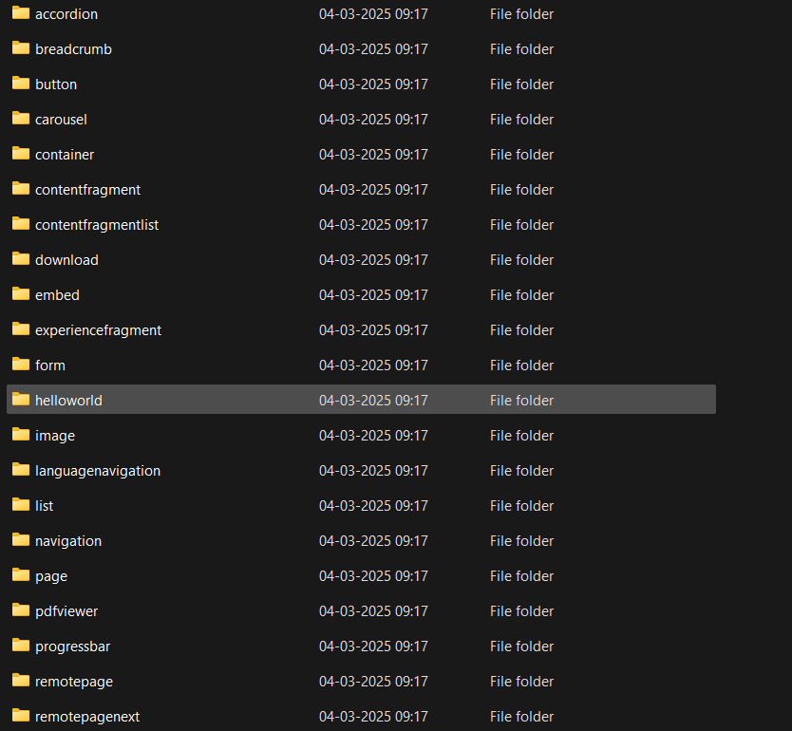

**Hello World Component:**

**Where is the Hello World component located in both core and ui.apps?**

In ui.apps :

F:\AEM\myTraining\ui.apps\src\main\content\jcr_root\apps\myTraining\components\helloworld

In core:

F:\AEM\myTraining\core\src\main\java\com\myTraining\core\models

In code it is inside the models folder.

**Explain the Java class (in core) for the Hello World component.**

In Java class in core it is a sling model that fetches properties.

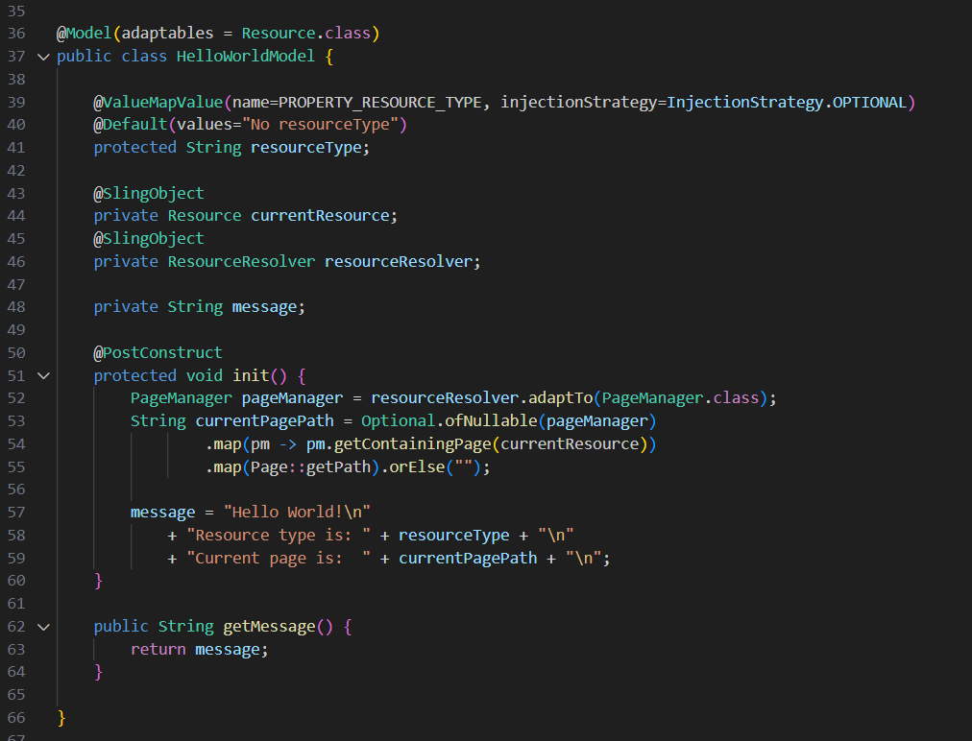

**How does the HTL script work in ui.apps for Hello World?**

The HTML fetches the data from the model

Ex:helloworld.html

**How are properties and dialogs defined for this component?**

The dialogs are defined for this component in q_dialog.xml,

properties are defined like this:

<text jcr:primaryType="nt:unstructured"

sling:resourceType="granite/ui/components/coral/foundation/form/textfield"

fieldLabel="Enter Text"

name="./text"/>

This creates a text field in the AEM dialog.

**What are the different types of AEM modules (core, ui.apps, ui.content, etc.)?**

**core** : Java logic

**ui.apps** : Components, dialogs, and clientlibs

**ui.content** : Sample content and templates

**ui.config** : OSGi configurations

**dispatcher** : Dispatcher rules

**How does Maven build these modules?**

Maven compiles the Java code first then packages it and then deploys it using predefined plugins.

Each module follows a format kind of process using the pom.xml.

**Explain the build lifecycle of Maven in the context of AEM.**

Maven has different phases like:

Clean- It deletes old build files in the system.

compile -It compiles Java code

install - Installs package locally

**How are dependencies managed in pom.xml?**

All dependencies are listed in **pom.xml** under:

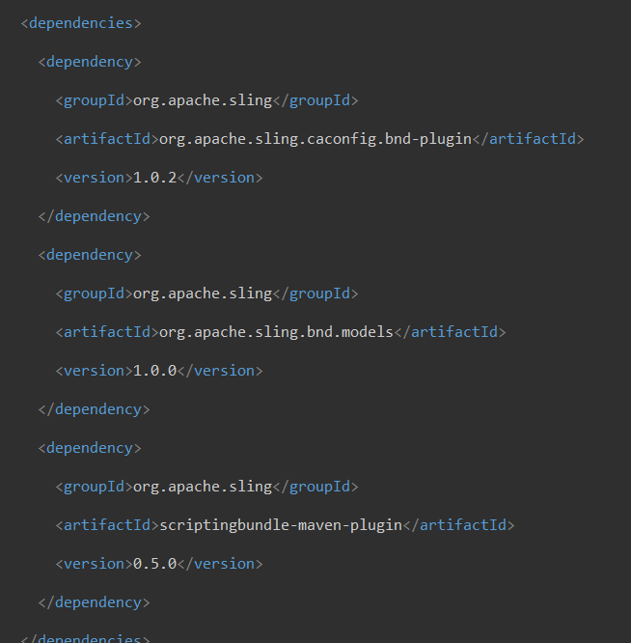

**Why is Maven used instead of other build tools?**

Maven is used because it works well with AEM archetypes, andHandles dependencies automatically and also in maven it we can automate the deployment so it the standardized for the AEM projects.

**What advantages does Maven offer for AEM development?**

Maven offer may advantages for the AEM development like it builds consistent project structures, it has easy CI/CD integration handles OSGI ect.

**How does Maven help in managing dependencies and plugins in AEM projects?**

In dependencies section it handles all the required library for the project.

In plugins section it is defining how AEM packages are built and deployed

**What does mvn clean install do in an AEM project?**

The mvn-clean will remove all the old files that sre build.

The mvn install will Compiles code, creates JAR/WAR, and installs it into AEM.

**How to deploy packages directly to AEM using Maven commands**?

Using this command we can deploy packages directly to aem :

mvn clean install -PautoInstallPackage -Dmaven.test.skip=true

**Explain the purpose of different Maven profiles in AEM (autoInstallPackage, autoInstallBundle).**

autoInstallPackage- This will deploy all the packages to aem.

autoInstallBundle- This will deploy only java bundle.

**What is the purpose of dumplibs in AEM?**

The dumplibs in AEM will helps debug client libraries liks css and js.

It will show all the loaded clientlibs and their paths.

**How can you view client libraries using dumplibs?**

Using this it will show all the libraries:

[**http://localhost:4502/etc.clientlibs/myTraining/dumplibs.html**](http://localhost:4502/etc.clientlibs/myTraining/dumplibs.html)

**Explain how client libraries are structured in AEM.**

In aem:

The libraries are structured base ,dependencies,grid,ect.

F:\AEM\myTraining\ui.apps\src\main\content\jcr_root\apps\myTraining\clientlibs

